Lab Sheet 01(Java Thread)
Task 01
public class SimpleThread extends Thread {
@Override
public void run() {
System.out.println(Thread.currentThread().getId() + " is executing the thread.");
}
public static void main(String[] args) {

SimpleThread thread1 = new SimpleThread();
SimpleThread thread2 = new SimpleThread();
thread1.start(); // Starts thread1
thread2.start(); // Starts thread2

}
}
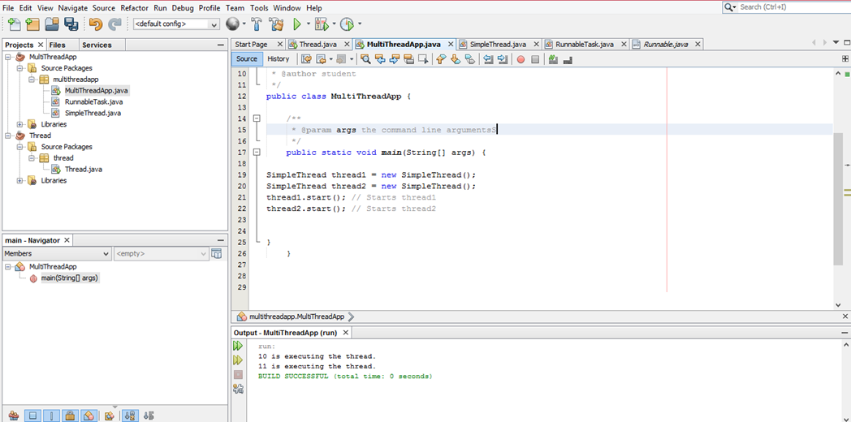

Task 02
public class RunnableTask implements Runnable {
@Override
public void run() {
System.out.println(Thread.currentThread().getId() + " is executingthe runnable task.");
}
}
public static void main(String[] args) {
RunnableTask task1 = new RunnableTask();
RunnableTask task2 = new RunnableTask();
Thread thread1 = new Thread(task1);
Thread thread2 = new Thread(task2);
thread1.start(); // Starts thread1
thread2.start(); // Starts thread2
}
}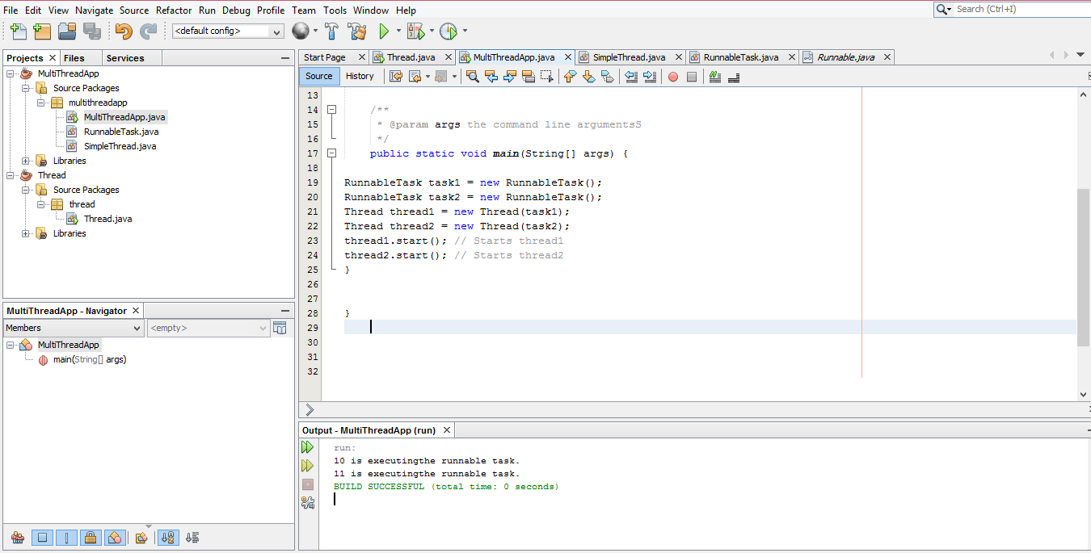

Task 03
public class counter {
private int count = 0;
// Synchronized method to ensure thread-safe access to the counter
public synchronized void increment() {
count++;
}
public int getCount() {
return count;
}
}
public class SynchronizedExample extends Thread {
private counter counter;
public SynchronizedExample(counter counter) {
this.counter = counter;
}
@Override
public void run() {
for (int i = 0; i < 1000; i++) {
counter.increment();
}
}
public static void main(String[] args) throws InterruptedException {
counter counter = new counter();
// Create and start multiple threads
Thread thread1 = new SynchronizedExample(counter);
Thread thread2 = new SynchronizedExample(counter);
thread1.start();
thread2.start();
// Wait for threads to finish
thread1.join();
thread2.join();
System.out.println("Final counter value: " + counter.getCount());
}
}
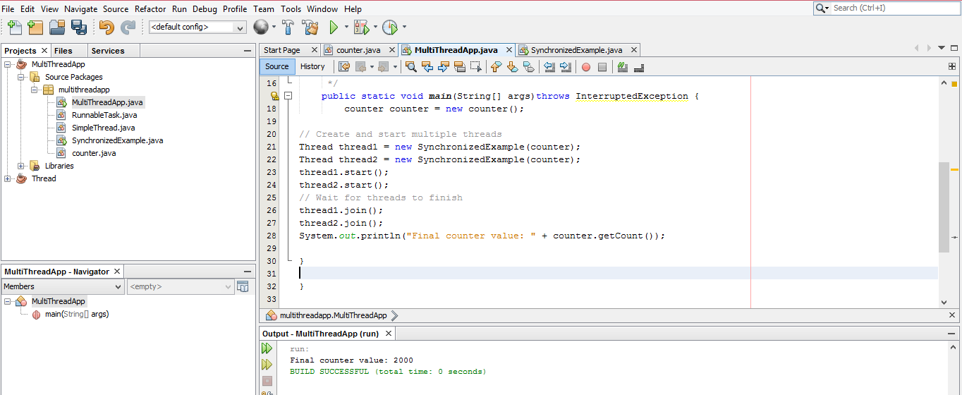

Task 04

import java.util.concurrent.ExecutorService;
import java.util.concurrent.Executors;

class Task implements Runnable {
private int taskId;
public Task(int taskId) {
this.taskId = taskId;
}

@Override
public void run() {
System.out.println("Task " + taskId + " is being processed by " +
Thread.currentThread().getName());
}
}

public class ThreadPoolExample {

public static void main(String[] args) {
// Create a thread pool with 3 threads
ExecutorService executorService = Executors.newFixedThreadPool(3);
// Submit tasks to the pool
for (int i = 1; i <= 5; i++) {
executorService.submit(new Task(i));
}
// Shutdown the thread pool
executorService.shutdown();
}
}
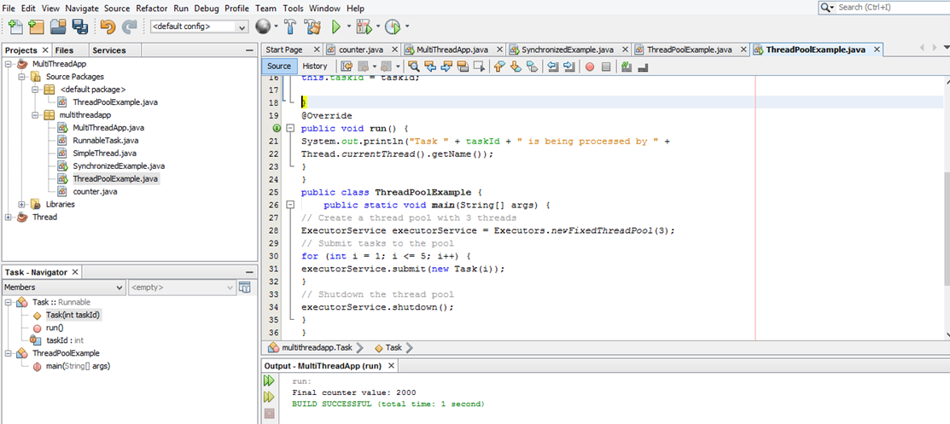

Task 05

public class ThreadLifecycleExample extends Thread {
@Override
public void run() {
System.out.println(Thread.currentThread().getName() + " - State: " +
Thread.currentThread().getState());
try {
Thread.sleep(2000); // Simulate waiting state
} catch (InterruptedException e) {
e.printStackTrace();
}
System.out.println(Thread.currentThread().getName() + " - State after
sleep: " + Thread.currentThread().getState());
}
public static void main(String[] args) {
ThreadLifecycleExample thread = new ThreadLifecycleExample();
System.out.println(thread.getName() + " - State before start: " +
thread.getState());
thread.start(); // Start the thread
System.out.println(thread.getName() + " - State after start: " +
thread.getState());
}
}
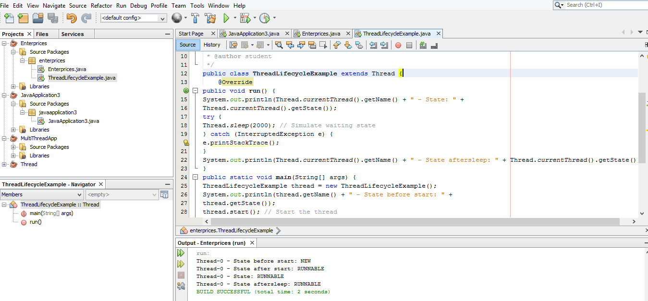

Lab Sheet 02(JDBC)
CREATE DATABASE employee_db;
USE employee_db;
CREATE TABLE employees (
id INT PRIMARY KEY AUTO_INCREMENT,
name VARCHAR(100),
position VARCHAR(100),
salary DECIMAL(10, 2)
);

INSERT INTO employees (name, position, salary) VALUES (” John Doe”,” Software
Engineer”, 75000);
INSERT INTO employees (name, position, salary) VALUES (“Jane Smith”,
“Manager”, 65000);
INSERT INTO employees (name, position, salary) VALUES (’’Steve Brown’’, ‘’Team
Lead’’, 85000);

package jdbcexample;
import java.sql.Connection;
import java.sql.DriverManager;
import java.sql.SQLException;

public class DatabaseConnection {
private static final String URL =
"jdbc:mysql://localhost:3306/employee_db"; // Database URL
private static final String USER = "root"; // Your MySQL username
private static final String PASSWORD = ""; // Your MySQL password public static Connection getConnection() throws SQLException {
public static Connection getConnection() throws SQLException {
try {
// Load the JDBC driver
Class.forName("com.mysql.cj.jdbc.Driver");
// Return the database connection
return DriverManager.getConnection(URL, USER, PASSWORD);
} catch (ClassNotFoundException | SQLException e) {
System.out.println("Connection failed: " + e.getMessage()); throw new SQLException("Failed to establish connection.");}
}
}public class Employee {
private int id;
private String name;
private String position;
private double salary;
public Employee(int id, String name, String position, double salary) { this.id = id;
this.name = name;
this.position = position;
this.salary = salary;
}
// Getters and setters
public int getId() { return id; }
public void setId(int id) { this.id = id; }
public String getName() { return name; }
public void setName(String name) { this.name = name; }
public String getPosition() { return position; }
public void setPosition(String position) { this.position = position; } public double getSalary() { return salary; }
public void setSalary(double salary) { this.salary = salary; }
@Override
public String toString() {
return "Employee{id=" + id + ", name='" + name + "', position='" + position + "', salary=" + salary + '}';
}
}
}package jdbcexample;
import java.sql.*;
import java.util.ArrayList;
import java.util.List;
/**
*
* @author student
*/
public class EmployeeDAO {
// Create an employee
public static void addEmployee(String name, String position, double salary) {
String sql = "INSERT INTO employees (name, position, salary) VALUES (?, ?, ?)";
try (Connection conn = DatabaseConnection.getConnection();
PreparedStatement stmt = conn.prepareStatement(sql)) {
stmt.setString(1, name);
stmt.setString(2, position);
stmt.setDouble(3, salary);
int rowsAffected = stmt.executeUpdate();
System.out.println("Employee added successfully. Rows affected: " + rowsAffected);
} catch (SQLException e) {
e.printStackTrace();
}
}
// Read all employees
public static List<Employee> getAllEmployees() {
List<Employee> employees = new ArrayList<>();
String sql = "SELECT * FROM employees";
try (Connection conn = DatabaseConnection.getConnection();
Statement stmt = conn.createStatement();
ResultSet rs = stmt.executeQuery(sql)) {
while (rs.next()) {
Employee employee = new Employee(rs.getInt("id"),
rs.getString("name"),
rs.getString("position"),
rs.getDouble("salary")
);
employees.add(employee);
}
} catch (SQLException e) {
e.printStackTrace();
}
return employees;
}
// Update an employee's information
public static void updateEmployee(int id, String name, String position, double salary) {
String sql = "UPDATE employees SET name = ?, position = ?, salary = ? WHERE id = ?";
try (Connection conn = DatabaseConnection.getConnection();
PreparedStatement stmt = conn.prepareStatement(sql)) {
stmt.setString(1, name);
stmt.setString(2, position);
stmt.setDouble(3, salary);
stmt.setInt(4, id);
int rowsAffected = stmt.executeUpdate();
System.out.println("Employee updated successfully. Rows affected: " + rowsAffected);
} catch (SQLException e) {
e.printStackTrace();
}
}
// Delete an employee
public static void deleteEmployee(int id) {
String sql = "DELETE FROM employees WHERE id = ?";
try (Connection conn = DatabaseConnection.getConnection();
PreparedStatement stmt = conn.prepareStatement(sql)) {
stmt.setInt(1, id);
int rowsAffected = stmt.executeUpdate();
System.out.println("Employee deleted successfully. Rows affected: " + rowsAffected);
} catch (SQLException e) {
e.printStackTrace();
}}
}import java.util.List;
/**
*
* @author student
*/
public class JDBCExample {

/**
* @param args the command line arguments
*/
public static void main(String[] args) {
// TODO code application logic here
EmployeeDAO.addEmployee("Alice Cooper", "Developer", 70000);
EmployeeDAO.addEmployee("Bob Marley", "Manager", 80000);
// Update employee
EmployeeDAO.updateEmployee(1, "John Doe", "Senior Software Engineer", 90000);
// Get all employees
List<Employee> employees = EmployeeDAO.getAllEmployees();
employees.forEach(System.out::println);
// Delete employee
EmployeeDAO.deleteEmployee(2);
}}import java.util.List;
/**
*
* @author student
*/
public class Main {
public static void main(String[] args) {
// Add employees
EmployeeDAO.addEmployee("Alice Cooper", "Developer", 70000);
EmployeeDAO.addEmployee("Bob Marley", "Manager", 80000);
// Update employee
EmployeeDAO.updateEmployee(1, "John Doe", "Senior Software Engineer", 90000);
// Get all employees
List<Employee> employees = EmployeeDAO.getAllEmployees();
employees.forEach(System.out::println);
// Delete employee
EmployeeDAO.deleteEmployee(2);
}
}
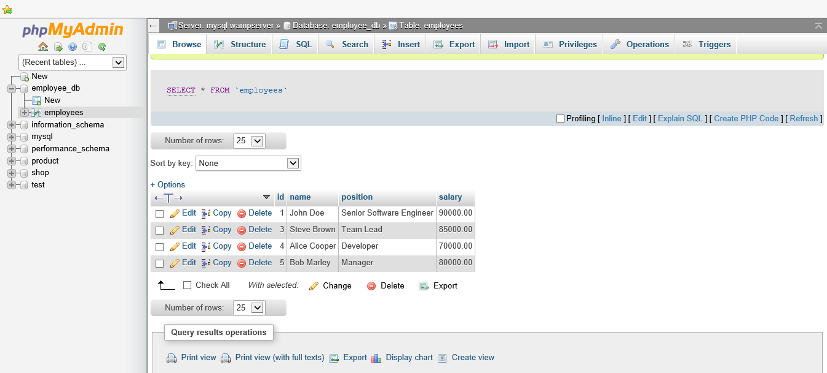
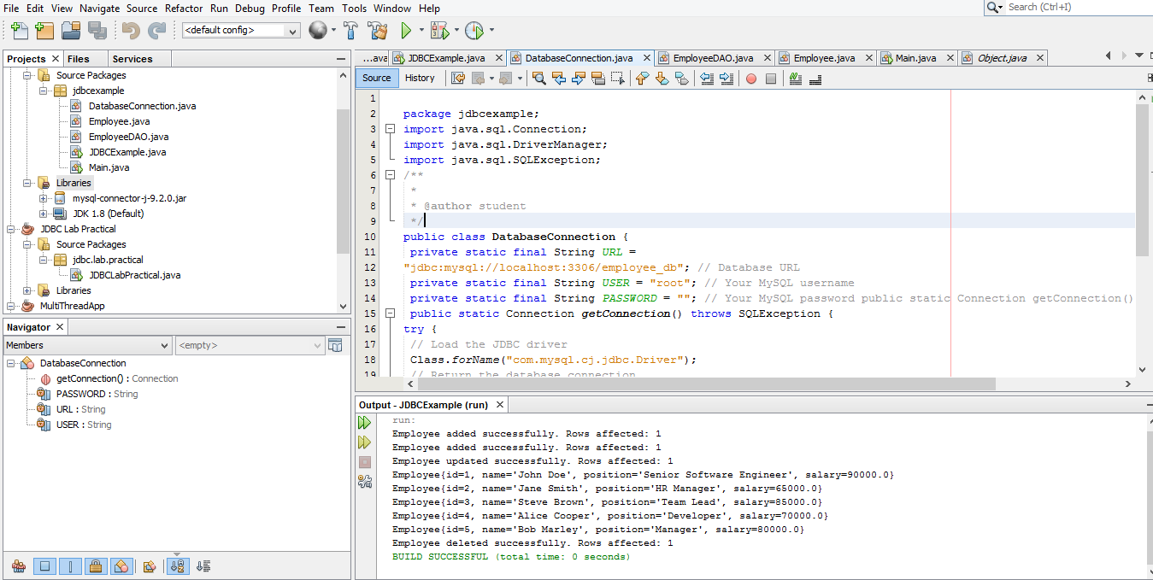

Lab Sheet 03(XML)
<?xml version="1.0" encoding="UTF-8"?>
<library>
<book>
<title>The Great Gatsby</title>
<author>F. Scott Fitzgerald</author>
<year>1925</year>
<genre>Fiction</genre>
</book>
<book>
<title>To Kill a Mockingbird</title>
<author>Harper Lee</author>
<year>1960</year>
<genre>Fiction</genre>
</book>
<book>
<title>1984</title>
<author>George Orwell</author>
<year>1949</year>
<genre>Dystopian</genre>
</book>
</library>
package javaapplication8;
import org.w3c.dom.*;
import javax.xml.parsers.*;
public class xmlparser {
public static void main(String[] args) {
try {
// Create a new DocumentBuilderFactory and DocumentBuilder
DocumentBuilderFactory factory = DocumentBuilderFactory.newInstance();
DocumentBuilder builder = factory.newDocumentBuilder();

// Parse the XML file
Document document = builder.parse("C:\\Users\\student\\Desktop\\0041\\JavaApplication8\\src\\javaapplication8\\books.xml");

// Normalize the document
document.getDocumentElement().normalize();

// Get the root element (library)
NodeList nodeList = document.getElementsByTagName("book");

// Loop through each book in the XML document
for (int i = 0; i < nodeList.getLength(); i++) {
Node node = nodeList.item(i);

if (node.getNodeType() == Node.ELEMENT_NODE) {
Element element = (Element) node;

// Get and print the details of each book
String title =
element.getElementsByTagName("title").item(0).getTextContent();
String author =
element.getElementsByTagName("author").item(0).getTextContent();
String year =
element.getElementsByTagName("year").item(0).getTextContent();
String genre =
element.getElementsByTagName("genre").item(0).getTextContent();

System.out.println("Title: " + title);
System.out.println("Author: " + author);
System.out.println("Year: " + year);
System.out.println("Genre: " + genre);
System.out.println("-----------");
}
}
} catch (Exception e) {
e.printStackTrace();
}
}
}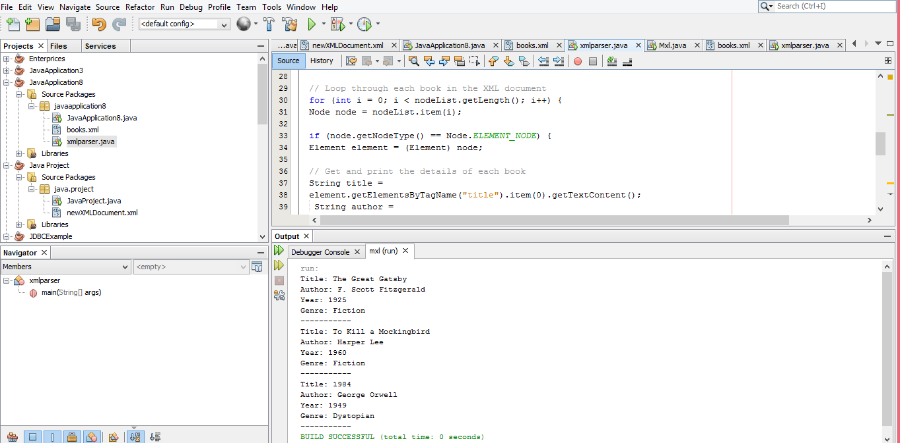

Update Task
package mxl;
import java.io.File;
import org.w3c.dom.*;
import javax.xml.parsers.*;
import javax.xml.transform.Transformer;
import javax.xml.transform.TransformerFactory;
import javax.xml.transform.dom.DOMSource;
import javax.xml.transform.stream.StreamResult;
/**
*
* @author student
*/
public class xmlparser {
public static void main(String[] args) {
try {
// Create a new DocumentBuilderFactory and DocumentBuilder
DocumentBuilderFactory factory = DocumentBuilderFactory.newInstance();
DocumentBuilder builder = factory.newDocumentBuilder();

// Parse the XML file
Document document = builder.parse("C:\\Users\\student\\Desktop\\0041\\mxl\\src\\mxl\\books.xml");

// Normalize the document
document.getDocumentElement().normalize();

// Get the root element (library)
NodeList nodeList = document.getElementsByTagName("book");

// Loop through each book in the XML document
for (int i = 0; i < nodeList.getLength(); i++) {
Node node = nodeList.item(i);

if (node.getNodeType() == Node.ELEMENT_NODE) {
Element element = (Element) node;

// Get and print the details of each book
String title =
element.getElementsByTagName("title").item(0).getTextContent();
String author =
element.getElementsByTagName("author").item(0).getTextContent();
String year =
element.getElementsByTagName("year").item(0).getTextContent();
String genre =
element.getElementsByTagName("genre").item(0).getTextContent();

System.out.println("Title: " + title);
System.out.println("Author: " + author);
System.out.println("Year: " + year);
System.out.println("Genre: " + genre);
System.out.println("-----------");
}
}
Element firstBook = (Element) nodeList.item(0);
firstBook.getElementsByTagName("year").item(0).setTextContent("2023");

// Save the modified document
TransformerFactory transformerFactory =
TransformerFactory.newInstance();
Transformer transformer = transformerFactory.newTransformer();
DOMSource source = new DOMSource(document);
StreamResult result = new StreamResult(new File("C:\\Users\\student\\Desktop\\0041\\mxl\\src\\mxl\\updated_books.xml"));
transformer.transform(source, result);
} catch (Exception e) {
e.printStackTrace();
}
}
}
<?xml version="1.0" encoding="UTF-8" standalone="no"?><library>
<book>
<title>The Great Gatsby</title>
<author>F. Scott Fitzgerald</author>
<year>2023</year>
<genre>Fiction</genre>
</book>
<book>
<title>To Kill a Mockingbird</title>
<author>Harper Lee</author>
<year>1960</year>
<genre>Fiction</genre>
</book>
<book>
<title>1984</title>
<author>George Orwell</author>
<year>1949</year>
<genre>Dystopian</genre>
</book>
</library>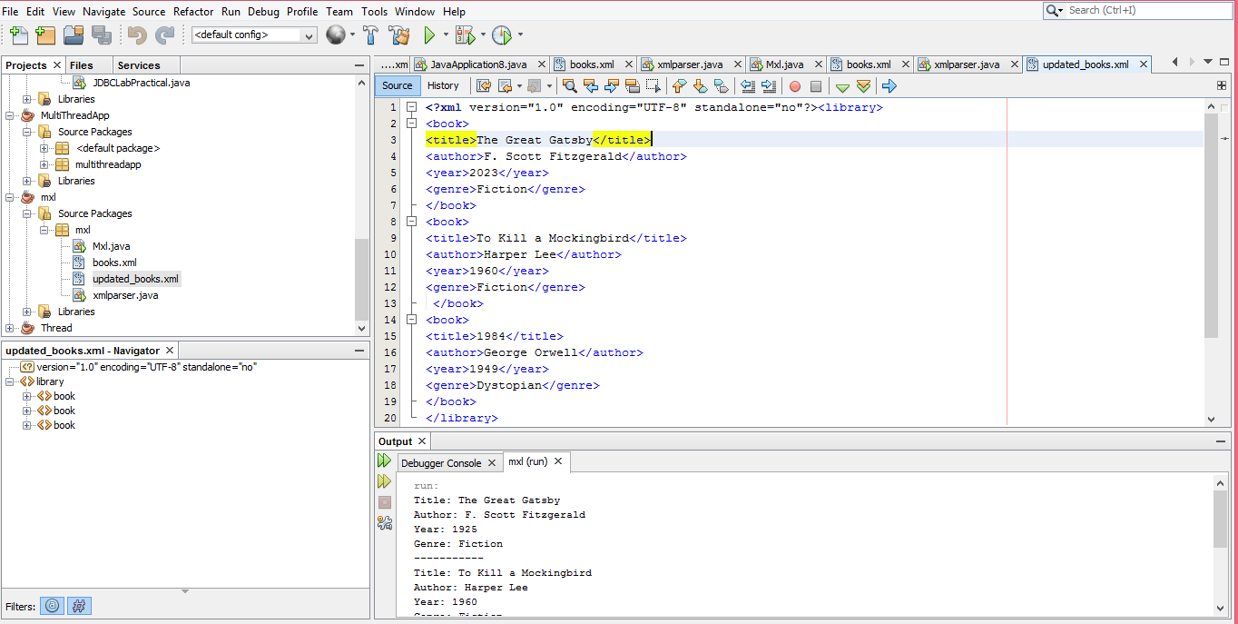
Lab Sheet 4: Simple Servlet
Task 1
package com.example;
import java.io.IOException;
import java.io.PrintWriter;
import javax.servlet.ServletException;
import javax.servlet.annotation.WebServlet;
import javax.servlet.http.HttpServlet;
import javax.servlet.http.HttpServletRequest;
import javax.servlet.http.HttpServletResponse;
@WebServlet("/displayMessage")
public class DisplayMessageServlet extends HttpServlet {
protected void doGet(HttpServletRequest request, HttpServletResponse
response)
throws ServletException, IOException {
response.setContentType("text/html");
PrintWriter out = response.getWriter();
out.println("<html><body>");
out.println("<h1>Welcome to the Java Servlet Lab!</h1>");
out.println("</body></html>");
}
}
<web-app xmlns="http://java.sun.com/xml/ns/javaee"
version="3.0">
<servlet>
<servlet-name>DisplayMessageServlet</servlet-name>
<servlet-class>com.example.DisplayMessageServlet</servlet-class>
</servlet>
<servlet-mapping>
<servlet-name>DisplayMessageServlet</servlet-name>
<url-pattern>/displayMessage</url-pattern>
</servlet-mapping>
</web-app>

Task 02

<html>

<head>

<title>user Input</title>

<meta charset="UTF-8">

<meta name="viewport" content="width=device-width,initial-scale=1.0">

</head>

<body bgcolor="gray">

<div><h1>User Input</h1></div>

<form action="getUserInput" method="POST">

<center><table style="width:70%">

<tr><th><h3>Name</h3></th><th><input type="text" name="unname"></th>

<tr><td colspan="2" align="center"><input type="submit" value="save"></td></tr>

</table></center>

</form>
</body>
</html>
Servlet Code (getUserInput.java):
package com.example;
import java.io.IOException;
import java.io.PrintWriter;
import javax.servlet.ServletException;
import javax.servlet.annotation.WebServlet;
import javax.servlet.http.HttpServlet;
import javax.servlet.http.HttpServletRequest;
import javax.servlet.http.HttpServletResponse;
@WebServlet("/getUserInput")
public class GetUserInputServlet extends HttpServlet {
protected void doPost(HttpServletRequest request, HttpServletResponse
response)
throws ServletException, IOException {
String name = request.getParameter("unname");
response.setContentType("text/html");
PrintWriter out = response.getWriter();
out.println("<html><body>");
out.println("<h1>Input name " + name + "!</h1>");
out.println("</body></html>");
}
}
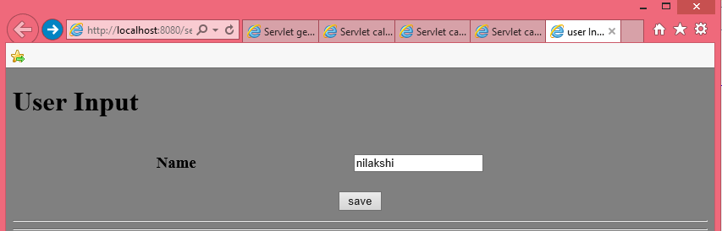
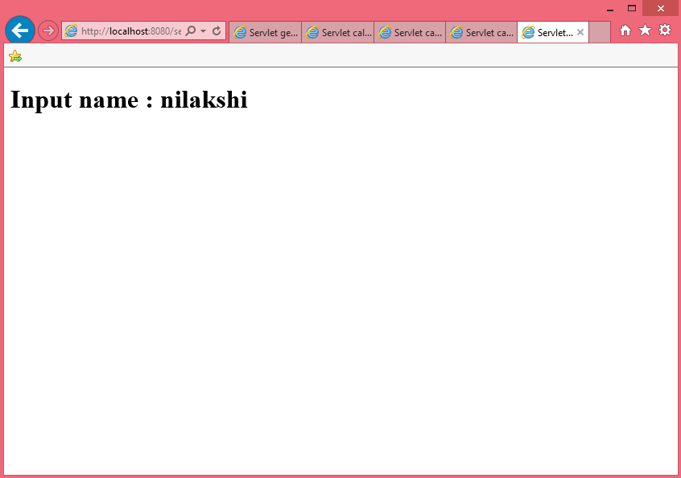
Task 3

<html>

<head>

<title>user Input</title>

<meta charset="UTF-8">

<meta name="viewport" content="width=device-width,initial-scale=1.0">

</head>

<h1> calculator</h1>

<form action="calculateSum" method="POST">

First Number: <input type="number" name="num1" required><br>

Second Number: <input type="number" name="num2" required><br>

<input type="submit" value="Calculate Sum">

</form>

</body>

</html>

import java.io.IOException;

import java.io.PrintWriter;

import javax.servlet.ServletException;

import javax.servlet.annotation.WebServlet;

import javax.servlet.http.HttpServlet;

import javax.servlet.http.HttpServletRequest;

import javax.servlet.http.HttpServletResponse;

@WebServlet(urlPatterns = {"/calculateSum"})

public class calculateSum extends HttpServlet {

* Processes requests for both HTTP <code>GET</code> and <code>POST</code>

* @param request servlet request

* @param response servlet response

* @throws ServletException if a servlet-specific error occurs

* @throws IOException if an I/O error occurs

*/

protected void processRequest(HttpServletRequest request, HttpServletResponse response)

throws ServletException, IOException {

int num1 = Integer.parseInt(request.getParameter("num1"));

int num2 = Integer.parseInt(request.getParameter("num2"));

int sum = num1 + num2;

response.setContentType("text/html;charset=UTF-8");

try (PrintWriter out = response.getWriter()) {

out.println("<!DOCTYPE html>");

out.println("<html>");

out.println("<head>");

out.println("<title>Servlet calculateSum</title>");

out.println("</head>");

out.println("<body>");

out.println("<h1>Calculate Sum</h1>");

out.println("<h3>First Number : " + num1 + "</h3>");

out.println("<h3>Second Number :" + num2 + "</h3>");

out.println("<h1>Answer " + sum + "</h1>");

out.println("</body>");

out.println("</html>");}}

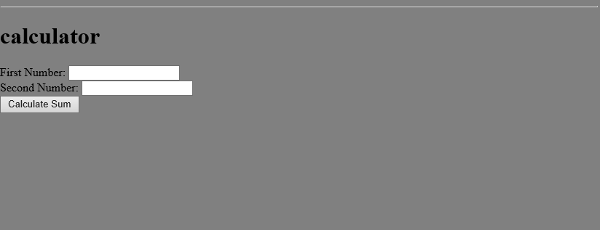

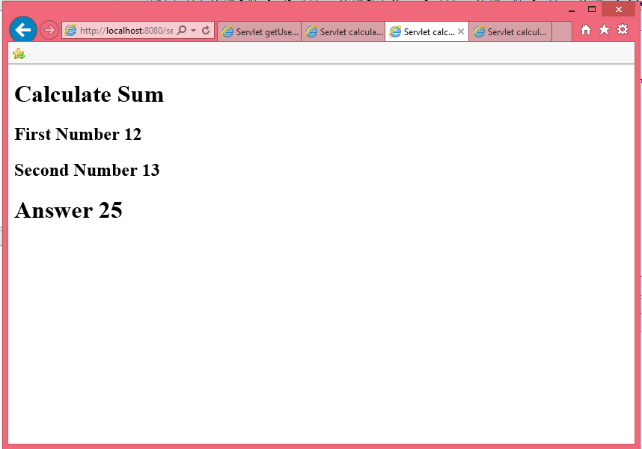
Task 4: Java Servlet with Database CRUD Operations
Database Setup
CREATE DATABASE stock_management;
USE stock_management;
CREATE TABLE stock (

id INT AUTO_INCREMENT PRIMARY KEY,
product_name VARCHAR(255),
quantity INT
);
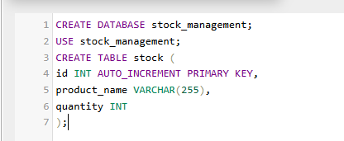

HTML Form (stockForm.html):
<!DOCTYPE html>
<html>
<head><title>Stock Management</title></head>
<body>
<h2>Manage Stock</h2>
<form action="stockAction" method="POST">
Product Name: <input type="text" name="product_name" required><br>
Quantity: <input type="number" name="quantity" required><br>
<input type="submit" name="action" value="Add Product">
<input type="submit" name="action" value="Update Product">
<input type="submit" name="action" value="Delete Product">
</form>
</body>
</html>
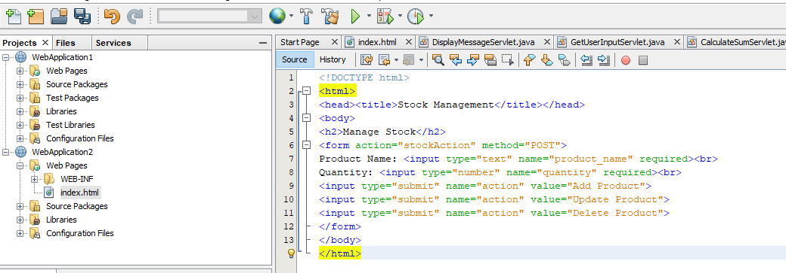

Servlet Code (StockManagementServlet.java):
package com.example;
import java.io.IOException;
import java.io.PrintWriter;
import java.sql.*;
import javax.servlet.ServletException;
import javax.servlet.annotation.WebServlet;
import javax.servlet.http.HttpServlet;

SLIATE HNDIT ENTERPRISE ARCHITECTURE 2 YEAR -2 SEMESTR
import javax.servlet.http.HttpServletRequest;
import javax.servlet.http.HttpServletResponse;
@WebServlet("/stockAction")
public class StockManagementServlet extends HttpServlet {
private Connection getConnection() throws SQLException {
String url = "jdbc:mysql://localhost:3306/stock_management";
String username = "root";
String password = "root"; // replace with your database password
return DriverManager.getConnection(url, username, password);
}
protected void doPost(HttpServletRequest request, HttpServletResponse
response)
throws ServletException, IOException {
String action = request.getParameter("action");
String productName = request.getParameter("product_name");
int quantity = Integer.parseInt(request.getParameter("quantity"));
try (Connection conn = getConnection()) {
switch(action) {
case "Add Product":
try (PreparedStatement stmt = conn.prepareStatement(
"INSERT INTO stock (product_name, quantity)
VALUES (?, ?)")) {
stmt.setString(1, productName);
stmt.setInt(2, quantity);
stmt.executeUpdate();

response.getWriter().write("<h1>Product Added

Successfully</h1>");
}
break;

case "Update Product":
try (PreparedStatement stmt = conn.prepareStatement(
"UPDATE stock SET quantity = ? WHERE product_name
= ?")) {
stmt.setInt(1, quantity);
stmt.setString(2, productName);

stmt.executeUpdate();

response.getWriter().write("<h1>Product Updated

Successfully</h1>");
}
break;

case "Delete Product":
try (PreparedStatement stmt = conn.prepareStatement(
"DELETE FROM stock WHERE product_name = ?")) {
stmt.setString(1, productName);

stmt.executeUpdate();

response.getWriter().write("<h1>Product Deleted
Successfully</h1>");
}
break;
default:
response.getWriter().write("<h1>Invalid Action</h1>");
}
} catch (SQLException e) {
e.printStackTrace();
response.getWriter().write("<h1>Database Error: " +
e.getMessage() + "</h1>");
}
}
}
}

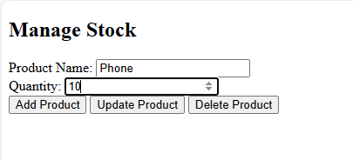

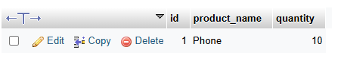

Lab Task 5: Display Data from Database on Another Web Page

Servlet Code (DisplayProductsServlet.java):
@WebServlet("/displayProducts")
public class DisplayProductsServlet extends HttpServlet {
protected void doGet(HttpServletRequest request, HttpServletResponse
response)
throws ServletException, IOException {
response.setContentType("text/html");
PrintWriter out = response.getWriter();
try (Connection conn = getConnection()) {
Statement stmt = conn.createStatement();
ResultSet rs = stmt.executeQuery("SELECT * FROM stock");
out.println("<html><body><h1>Stock List</h1>");
while (rs.next()) {
out.println("<p>" + rs.getString("product_name") + ": " +
rs.getInt("quantity") + "</p>");
}
out.println("</body></html>");
} catch (SQLException e) {
e.printStackTrace();
out.println("<h1>Database Error</h1>");
}
}
}

